

**Off. No.: 42, 1st C.P Market, Behind Ansal Plaza Pari Chowk**

**Greater Noida (India)**

**Contact us:**

**+91-9990171401**

**+91-9718870012**

**E-Mail - sintecht@gmail.com**

[**www.sintecht.com**](http://www.sintecht.com)

**Advance**

**Bank Security system**

**Abstract**

IR devices can detect a person moving into or through a detection zone with high reliability. The slightest positive or negative thermal radiation change in contrast to a background, focused by the appropriate optics, triggers the sensor element. There is no interference between neighboring units due to the passive nature of the detection principle. The use of differential or dual-channel sensor technology and advanced digital signal processing reduce false alarms caused by turbulence. Similarly, precision optics accurately defines the field of view, allowing consistent and long-range coverage.

Utilizing IR sensor we are going to present our final year project “IR based bank security system ”. We consider specific area around which no one is allowed to enter. When any one enter in this specific area, the exit gate automatically get closed, voice warning (Our recording) starts playing and also our system deliver a voice massage to the police station for further operation. We use IR sensor to sense motion around the secured region, processing is done using PIC microcontroller.

**Bank security System**

**Introduction:**

IR devices can detect a person moving into or through a detection zone with high reliability. The slightest positive or negative thermal radiation change in contrast to a background, focused by the appropriate optics, triggers the sensor element. There is no interference between neighboring units due to the passive nature of the detection principle. The use of differential or dual-channel sensor technology and advanced digital signal processing reduce false alarms caused by turbulence. Similarly, precision optics accurately defines the field of view, allowing consistent and long-range coverage.

Utilizing IR sensor we are going to present our final year project “IR based bank security system ”. We consider specific area around which no one is allowed to enter. When any one enter in this specific area, the exit gate automatically get closed, voice warning (Our recording) starts playing and also our system deliver a voice massage to the police station for further operation. We use IR sensor to sense motion around the secured region, processing is done using PIC microcontroller.

**Block diagram:**

timer

PIC

Microcontroller

IR

Sensor

**BUZZER**

LCD DISPLAY

IR

Sensor

timer

ENCODER

TX

RX

IR

Sensor

timer

Phone call

timer

IR

Sensor

**Circuit diagram(Transmitter):**

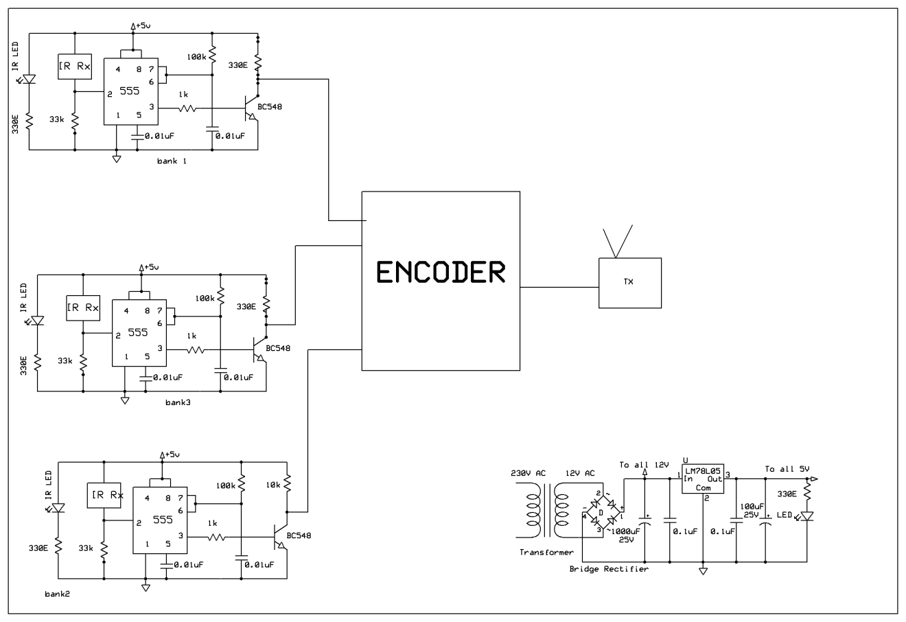

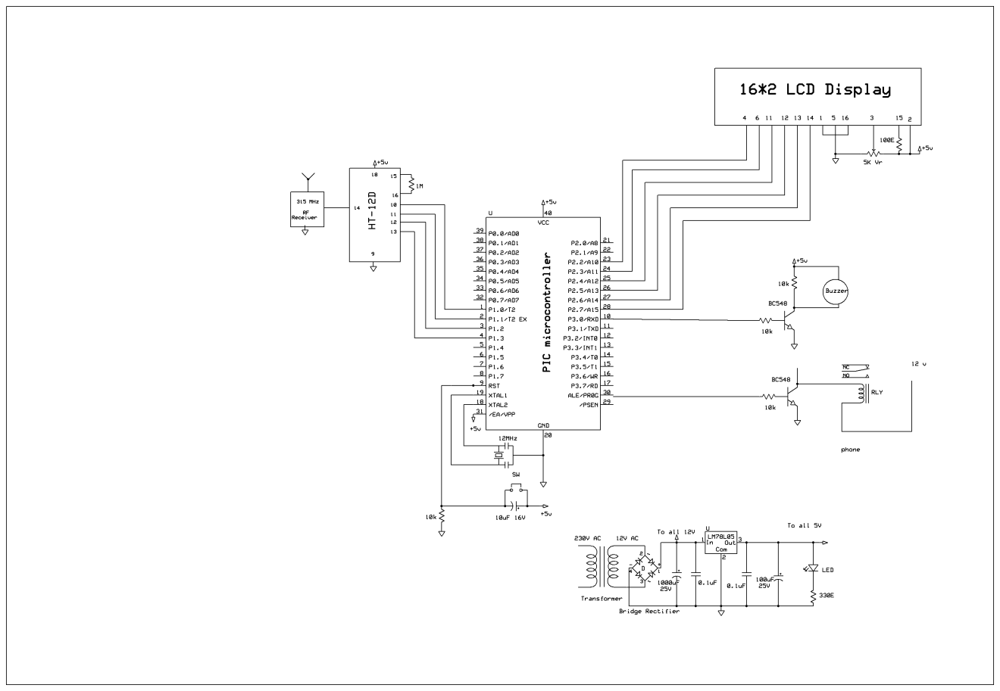**Receiver:-**

**Working:-**

The IR sensor is used to sense some unknown person like thief entering in your house without your permission.

In the infrared sensor we use IC 555 as a main component. Pin no 8 is connected to the positive supply. Pin no 4 is connected to the negative voltage. One capacitor is grounded from the pin no 3 for noise cancellation. Output is available on the pin no 1. Sensor is connected to the pin no 3.

In the case of infra red sensor Pin no 2 is negative bias and pin no 1 is positively biased.

In normal stage when a person is sensed by IR then pin no 2 is positively biased photodiode. If pin no 2 is positive then negative output is available on the pin no 3. Now when any body interrupts the light then there is no light on the photodiode and pin no 2 is now gets its voltage from only 5.6 k ohm resistor. If pin no 2 is become negative then output is shifted to the pin no 3. When positive output is available on the pin no 3 and with the help of this voltage NPN transistor is on and npn transistor provide a negative voltage as a pulse to the microcontroller (pin No 39)

Component used:-

Lcd

Avr micro-controller

Diode

Led

Capacitor

555 ic

Ir sensor

Transistor

Lm 7805

CONCLUSION

This is a real time application based paper which tells that there isa need to bring in a revolution in the bank locker security system by making the procedure a little easy and more systematic for the bank offcials. This is just a proposed model whch when implemented would surely give a very good protection of the lockers curbing theft and making the lockers more reliable. the assurance it will give to the bank customers will force them to use it and hence protect their valuables from theft or any kind of robbery. This not aims at easing the work load of the bank official but also makes it a easy and comfortable process for its users, the general public. As this is protected by the vicinity sensor hence can detect any unwanted or forced entry inside the bank locker area and can protect the lockers n the lockers in the most efficient way.